Name:________________ Retell the Story RL 1.2

Think about how the pigeon felt in The Pigeon Needs a Bath. How did he feel at the beginning, middle, and end of the book? Describe his feelings in the bubbles below.

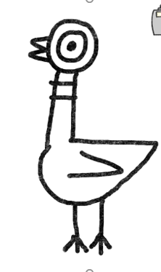
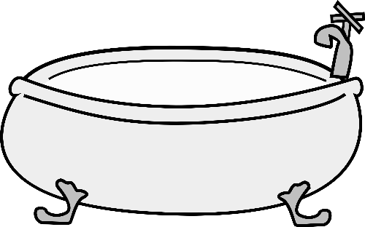
Middle:
End:
Beginning:

