Name:__________________________

Does the pigeon need a bath? Justify your answers with evidence from the story. Write or draw your answers in the boxes below.

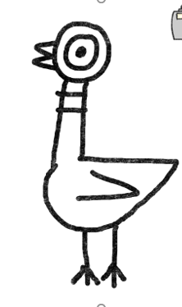

YES Or No

1.
3.
2.

