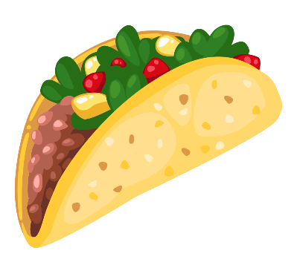
Name:___________________________________
Book Bingo
See me at the front desk when you complete a task for a sticker to cover a spot. Be prepared to taco about that book. On the back of this page, write down the titles of the books you read. When you have a bingo (5 in a row), see your librarian for a prize.
Read a graphic  novel.  (Comic style) | Read a non-fiction book about outer space. | Read a biography.  (A book about  a famous  person.) | Read a book recommended by a parent/relative. | Read a fairy tale.
Read a picture book on your level. | Read a book about an animal you’re curious about. | Read a chapter book with at least  50 pages. | Read a book about a pet  You might like to have. | Try out a drawing book. Show me your  picture.
Try out an ISpy  book. Tell me if you found everything on one page. | Read a book  about a sport.  It can be  Fiction or Non-Fiction. | Free Choice.  Read any type of book you want. | Read a book about a country  you might like to visit. | Read a chapter book that has magic or a magical creature.
Read a book recommended by you classroom teacher. | Read a book that has to do with history. Real or historical fiction. | Read a book with a mystery. | Read a book recommended by a friend. | Read the first book in a series.
Read a book with a non-human character. | Read a book with a cool cover. | Read a book that is during a holiday or season. | Read a DIY (Do it Yourself) book where you learn how to do something. | Read a book on something you know nothing about.
Book Titles You’ve Read.
1._______________________________________________
2.________________________________________________
3._________________________________________________
4.__________________________________________________
5.__________________________________________________
6.___________________________________________________
7.___________________________________________________
8.___________________________________________________
9.__________________________________________________
10.___________________________________________________
11.___________________________________________________
12.____________________________________________________
13.____________________________________________________
14.___________________________________________________
15.____________________________________________________
16.___________________________________________________
17.___________________________________________________
18.____________________________________________________
19.____________________________________________________
20.____________________________________________________

